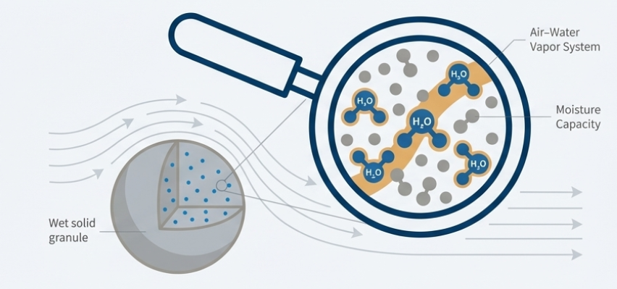
Drying
In pharmaceutical manufacturing, drying is defined as the removal of a liquid from a material by applying heat, which transforms the liquid into an unsaturated vapor phase.
While this usually refers to removing small amounts of water, it is distinguished from evaporation by the relative quantity of liquid removed; evaporation typically involves removing large volumes of water. There are also non-thermal methods, such as desiccation (using silica gel in a sealed container) or expression (squeezing a solid to remove liquid).
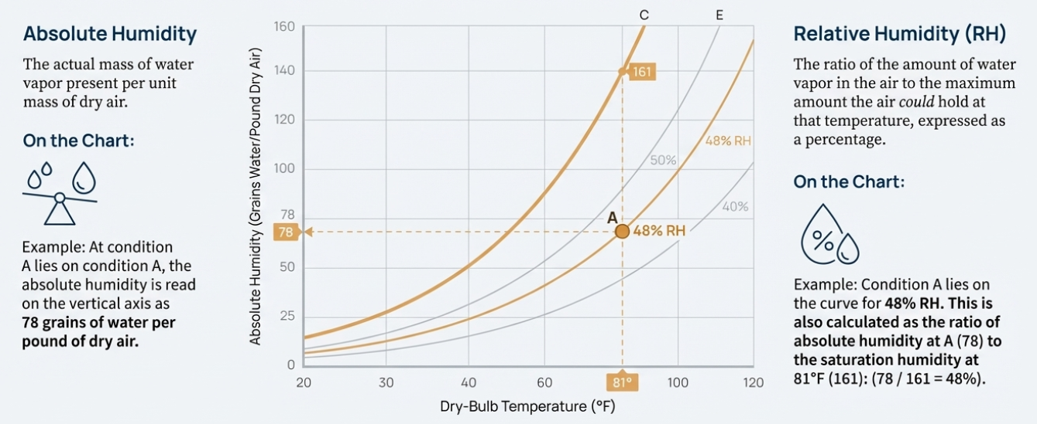
Purpose of Drying
Drying is a critical unit process for several reasons:
- Preparation of Granules: Essential for making tablets and capsules.
- Stability and Preservation: Dried products are generally more stable, as drying reduces chemical reactivity and prevents the growth of mold and bacteria in moisture-sensitive animal or vegetable drugs.
- Processing Efficiency: Drying makes substances more friable (brittle), which makes them easier to grind or pulverize.
- Cost Reduction: Removing moisture reduces the bulk and weight of a product, lowering transportation and storage costs.
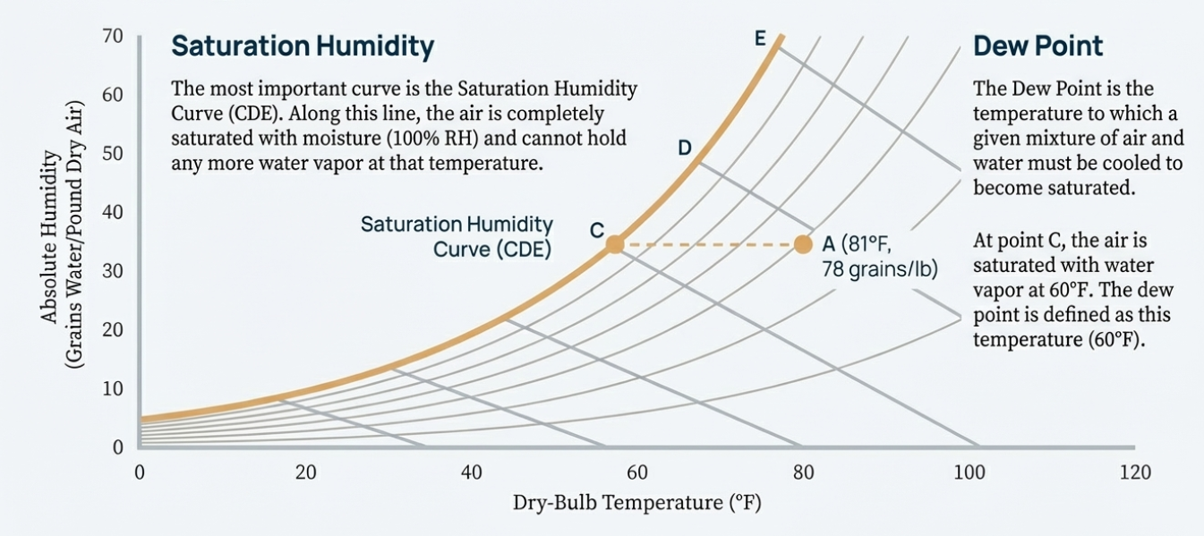
Fundamental Theory: Heat and Mass Transfer
The drying process is governed by two simultaneous operations: heat transfer and mass transfer.
- Heat Transfer: Heat must be moved to the material to provide the "latent heat of vapourization" required to turn the liquid into vapor. This can happen via convection (hot air), radiation (heat lamps), or conduction (direct contact with a hot surface).
- Mass Transfer: This involves the movement (diffusion) of water through the material to its surface, followed by the evaporation of that water into the surrounding air stream.
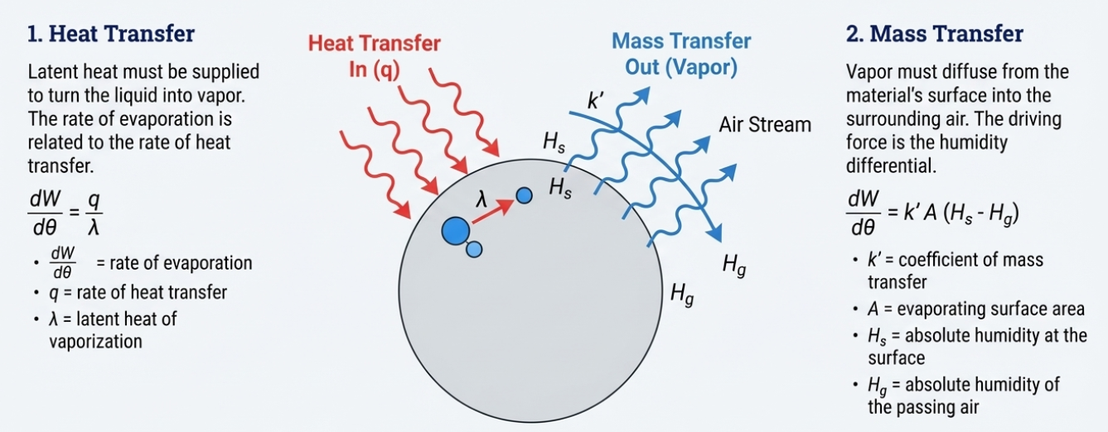
The rate of drying can be accelerated by increasing the air flow rate, raising the inlet air temperature, reducing the thickness of the material, or dehumidifying the inlet air.
Measuring Moisture: LOD vs. MC
In pharmacy, moisture is measured in two ways:
- Loss on Drying (LOD): Calculated on a wet-weight basis. It is the weight of water in a sample divided by the total weight of the wet sample, multiplied by 100.
- Moisture Content (MC): Calculated on a dry-weight basis. It is the weight of water divided by the weight of the dry solid, multiplied by 100.
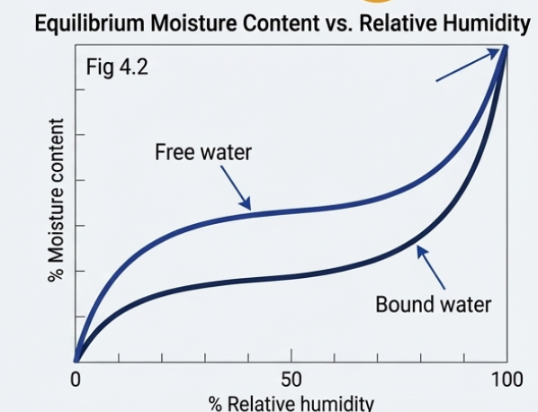
Additionally, pharmacists distinguish between Loss on Drying (LOD), which calculates moisture as a percentage of the wet weight, and Moisture Content (MC), which uses the dry weight. MC is considered a more realistic value for determining dryer load capacity because it more accurately reflects the amount of water that must be evaporated per pound of dry product.
- Equilibrium Moisture Content (EMC): The moisture content at which a material is in perfect equilibrium with its environment. At this point, the drying rate is zero, and further drying is a waste of energy.
- Free Water: Any moisture present in excess of the EMC.
- Bound Water: Water held in small capillary pores or adsorbed on the surface. This water exerts a lower vapor pressure than pure water.
- Water Activity (a_{w}): The ratio of the vapor pressure of the material to the vapor pressure of pure water. It is a key measure for determining chemical stability and the potential for microbial growth.
The Stages of Drying (Drying Rate Curve)
When a solid dries, it moves through several distinct stages, often visualized as a "drying rate curve":
- Initial Adjustment (Segment AB): The material absorbs heat and stabilizes at the wet-bulb temperature of the drying air.
- Constant Rate Period (Segment BC): A film of moisture remains on the surface of the solid. As water evaporates, it is immediately replaced by water diffusing from the interior. The drying rate remains steady.
- Critical Moisture Content (Point C): This is the point where the surface water is no longer replaced fast enough to maintain a continuous film. Dry spots begin to appear.
- First Falling Rate Period (Segment CD): The number of dry spots grows, and the drying rate begins to drop steadily.
- Second Falling Rate Period (Segment DE): The surface film is completely gone. Drying now depends entirely on how fast vapor can diffuse through the pores of the solid.
- Equilibrium Moisture Content (EMC): The final stage where the material's vapor pressure equals that of the surrounding atmosphere, and drying stops.
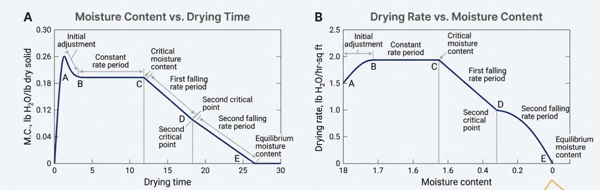
Behavior of Different Solids
The ease of drying depends on the type of solid:
- Granular or Crystalline Solids: These hold water in shallow, open pores. They are easy to dry, have a long constant-rate period, and their EMC is near zero.
- Amorphous Solids: These include fibrous or gelatinous materials like starch, insulin, or yeast. The moisture is part of their molecular structure, making movement very slow. They are much more difficult to dry and often require reduced pressure or specialized temperatures.
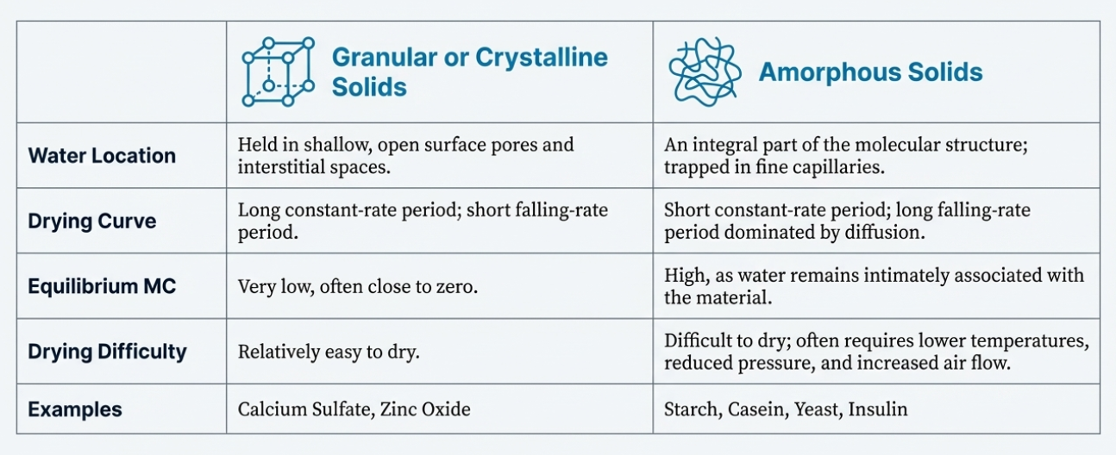

Drying Equipments:
Drying apparatuses in pharmaceutical manufacturing are primarily classified by their method of solids handling, which determines how the material interacts with the heating medium and moves through the system. These systems are categorized into four major types: static-bed, moving-bed, fluidized-bed, and pneumatic dryers.
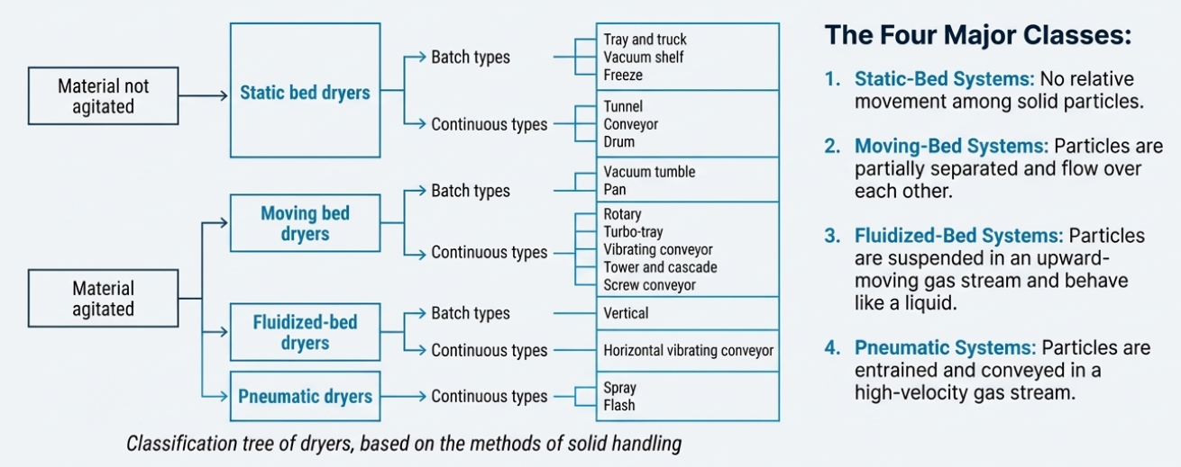
1. Static-Bed Systems
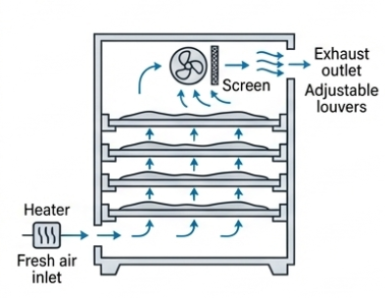
In these systems, there is no relative movement among the solid particles being dried, though the entire mass may move.
A. Tray and Truck Dryers
- Introduction: These are the most common dryers in pharmaceutical plants. A tray dryer uses a cabinet with tiers of trays, while a truck dryer uses racks on wheels for easier loading.
- Mechanism: They operate primarily through forced convection, where large volumes of heated air are circulated over the material.
- Construction: These consist of a well-insulated cabinet with heaters (steam or electric), fans to circulate air, and adjustable louvers.
- Working: Material is spread on trays (0.5 to 4 inches deep). Heated air circulates at 200 to 2,000 feet per minute.
- Limitation: They provide a low drying rate and are labor-intensive. They can also suffer from non-uniform airflow and "stagnant pockets".
- How to Overcome: Using adjustable louvers helps eliminate stagnant pockets and ensures more uniform airflow.
- Advantages: They allow each batch to be handled as a separate entity and are easily adjusted for a wide variety of materials.
- Pharmaceutical Applications: General drying of powders and chemicals where batch sizes are relatively small.

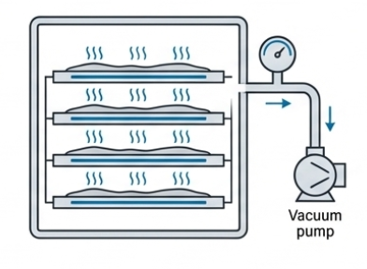
B. Vacuum Shelf Dryers
- Introduction: These are similar to tray dryers but operate under low pressure, making them an alternative for small quantities of sensitive material.
- Mechanism: By reducing pressure below the saturation pressure of the solvent, the boiling point of the liquid is lowered, causing rapid vaporization.
- Construction: Heavy-duty cabinets with hollow shelves that can be heated by steam or hot water.
- Working: Material is placed on shelves, the chamber is sealed, and a vacuum is applied. Heat is transferred by conduction from the shelves to the material.
- Limitation: They require massive construction and have high costs and long drying times (12 to 48 hours).
- Advantages: Ideal for low-temperature drying of heat-sensitive (thermolabile) materials and for excluding oxygen to prevent oxidation.
- Pharmaceutical Applications: Drying penicillin and materials requiring solvent recovery.
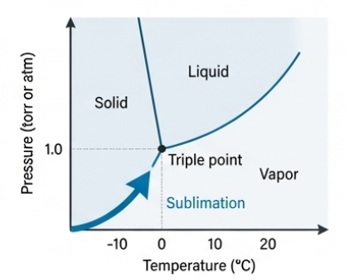
C. Freeze Dryers (Lyophilization)
- Introduction: Used for products that lose viability or deteriorate if dried in air at normal pressures.
- Mechanism: Based on sublimation, where water passes directly from a solid state (ice) to a vapor state without becoming a liquid.
- Construction: Includes a vacuum chamber, a vacuum source, a heat source (conduction or radiation), and a vapor-removal system (condenser).
- Working: Material is pre-frozen (below -20°C). A high vacuum is applied, and heat is added to sublimate the ice (primary drying). Finally, the temperature is raised to remove bound water (secondary drying).
- Limitation: It is an expensive and complex process.
- Advantages: Stabilizes highly sensitive biological materials that cannot withstand heat.
- Pharmaceutical Applications: Blood serum, plasma, antibiotics, vaccines, and hormones.
D. Tunnel and Conveyor Dryers
- Introduction: These are adaptations of truck dryers for continuous or semi-continuous operation.
- Mechanism: Convection-based drying.
- Construction: A long tunnel through which trucks (tunnel dryer) or an endless belt (conveyor dryer) moves the material.
- Working: In a conveyor dryer, wet material is loaded onto a belt that carries it through a tunnel where heated air is circulated.
- Limitation: Drying rate curves for batch drying are not equally applicable here because air conditions change as the material moves along the path.
- Advantages: Conveyor dryers are truly continuous and suitable for handling large volumes of material.
- Pharmaceutical Applications: Large-scale manufacturing of uniform materials.
2. Moving-Bed Systems
In these systems, particles are partially separated so that they flow over each other, creating new surfaces for faster heat transfer.
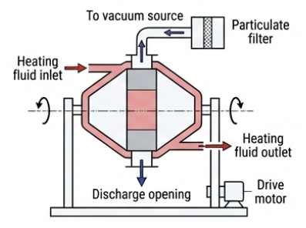
A. Vacuum Tumble Dryers
- Introduction: Often double-cone shaped, these mixers are designed to overcome the long drying times of static dryers.
- Mechanism: Combined conduction and heat transfer through vapor under vacuum.
- Construction: A rotating double-cone shell with a jacket for heating fluid.
- Working: The shell rotates (6–8 rpm) while heat is applied through the jacket walls. The tumbling action constantly exposes new material to the heat.
- Limitation: Waxy solids may aggregate into balls. Larger models may have less jacket area relative to the volume of material.
- How to Overcome: Larger models can use internal plates or pipe coils to increase the surface area for heat transfer.
- Advantages: Faster than static ovens and produces a uniform powder rather than a cake.
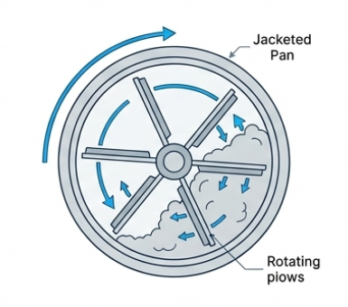
- Pharmaceutical Applications: Drying tablet granules.
B. Pan Dryers
- Introduction: These are indirect-type dryers used for small batches.
- Mechanism: Conduction.
- Construction: A shallow, circular jacketed pan with rotating plows.
- Working: Plows rotate slowly, scraping the material from the walls and exposing new surfaces to the heated bottom.
- Advantages: Can operate under a vacuum for solvent recovery.
- Pharmaceutical Applications: Pastes and slurries.
C. Rotary Dryers
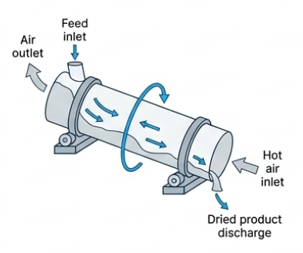
- Introduction: A modified form of a tunnel dryer where material is actively turned.
- Mechanism: Convection.
- Construction: A sloped rotating cylindrical shell with internal baffles or "flights".
- Working: Material is passed through the rotating cylinder against a stream of heated air. The baffles turn the material over as it moves.
- Advantages: Continuous operation with better drying rates than static beds.
- Pharmaceutical Applications: Large volumes of solid materials.

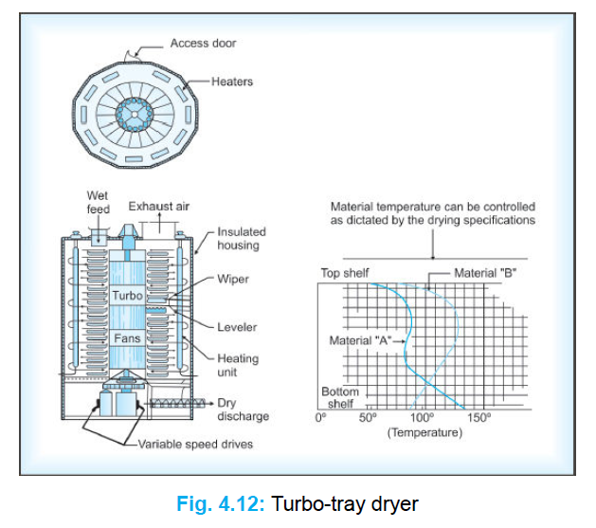
D. Turbo-Tray Dryers
- Introduction: A continuous, moving-bed system featuring vertical stacks of trays.
- Mechanism: Convection.
- Construction: Rotating annular trays in a vertical stack with stationary wipers and fans.
- Working: Material is fed to the top tray, leveled, and then wiped through slots to the tray below. This repeats until the material is discharged at the bottom.
- Advantages: Faster drying rates than tunnel dryers because it continuously exposes new surfaces.
- Pharmaceutical Applications: Continuous processing of solids.
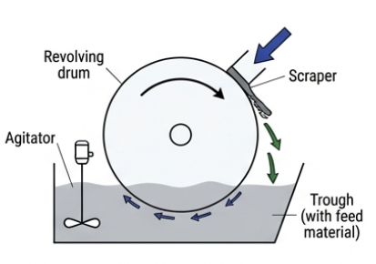
E. Drum Dryers
- Introduction: These use rotating cylinders to dry solutions or slurries.
- Mechanism: Drying occurs through simple evaporation.
- Construction: One or two steam-heated cylinders that rotate slowly, a feed trough, and a scraper blade.
- Working: The rotating drum is coated with the liquid feed. As it turns, the liquid evaporates, and the dried solid is scraped off by the blade.
- Limitation: They can subject solids to greater heat treatment than spray dryers.
- Advantages: They offer a short contact time, which is advantageous for some thermolabile materials.
- Pharmaceutical Applications: Drying kaolin or zinc oxide suspensions.

3. Fluidized-Bed Systems
Particles are partially suspended in an upward-moving gas stream, behaving like a "boiling liquid".
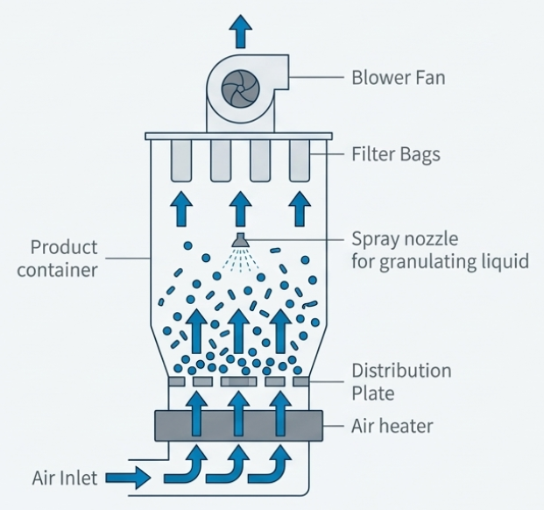
A. Vertical Fluidized-Bed Dryers
- Introduction: These systems offer intense mixing and uniform conditions.
- Mechanism: Excellent gas-solid contact for high heat and mass transfer.
- Construction: A container with a wire mesh bottom, an air heater, a fan, and a bag collector filter.
- Working: Heated air is blown upward through the material at a speed greater than the particles' settling velocity, causing them to "boil" in the air stream.
- Limitation: Can build up electrostatic charges; overly friable material may produce fine particles through attrition.
- How to Overcome: Grounding devices are used to avoid explosion hazards from static electricity.
- Advantages: 2 to 6 times faster and more efficient than tray dryers.
- Pharmaceutical Applications: Drying and preparing tablet granulations.
B. Horizontal Vibrating Conveyors
- Introduction: A continuous version of the fluidized-bed dryer suitable for large volumes.
- Mechanism: Combined fluidization and vibration.
- Construction: A horizontal vibrating deck with multiple zones for independent airflow and temperature control.
- Working: Material is moved along the vibrating deck while heated air is passed up through it from a chamber below.
- Advantages: High capacity (up to 2 tons per hour) and allows for specialized drying zones. Dryers vary in width from 12 to 57 inches and in length from 10 to 50 feet, with bed depths of 3 inches. Dryer capacity is limited only by the retention time produced by conveying speeds, which range from 5 to 25 feet per minute.
- Pharmaceutical Applications: Large-volume pharmaceutical operations.
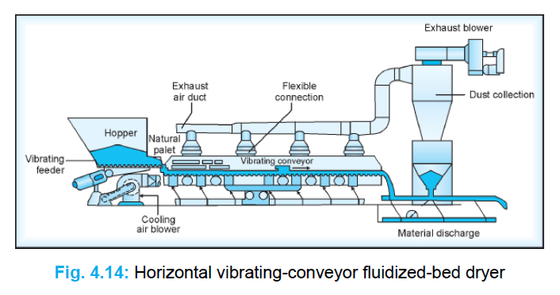

4. Pneumatic Dryers
In these dryers, particles are entrained (carried) and conveyed in a high-velocity gas stream.
A. Spray Dryers
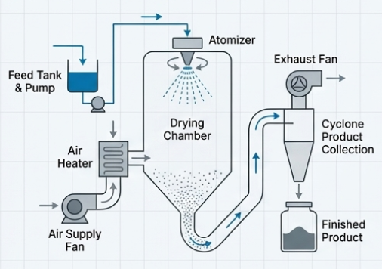
- Introduction: Specifically designed to handle fluid materials like solutions and slurries.
- Mechanism: Extremely rapid evaporation from fine droplets.
- Construction: Includes a feed pump, an atomizer (pneumatic, nozzle, or spinning disc), a drying chamber, and a cyclone separator.
- Working: Liquid is atomized into a stream of hot gas. The droplets dry into fine powder in seconds and are collected by the cyclone.
- Limitation: Viscous liquids can clog some atomizers.
- How to Overcome: Use spinning disc atomizers to handle high-viscosity liquids and slurries that would clog other types.
- Advantages: Rapid drying (seconds) keeps the product cool; produces uniform, spherical particles with excellent flow properties.
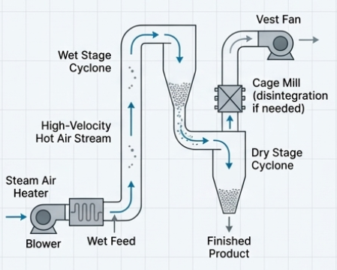
- Pharmaceutical Applications: Spray-dried lactose, vitamins, and encapsulating "dry" flavor oils.
B. Flash Dryers
- Introduction: These provide extremely short drying times (seconds).
- Mechanism: Attrition and convection in high-velocity air.
- Construction: A duct system with high-velocity air (3,000–6,000 ft/min) and a cyclone separator.
- Working: Moistened solid is suspended in the hot air stream. The high velocity causes particles to strike each other, exposing new surfaces for instant drying.
- Advantages: Very fast; the temperature of the drying solid can be kept very low (below 100°F) despite high air temperatures.
- Pharmaceutical Applications: Drying friable materials where particle size reduction is also desired.
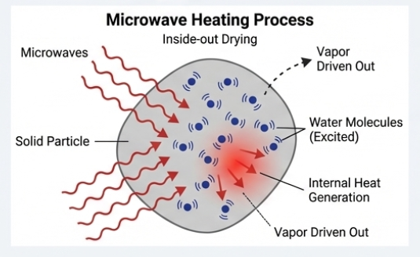
5. Specialized Drying: Microwave Drying
- Introduction: A radical departure that uses microwave energy instead of external heat.
- Mechanism: Microwaves interact with polarized molecules to generate internal heat.
- Construction: Typically a static-bed continuous type with a conveyor belt and microwave applicators.
- Working: Microwaves generate internal vapor pressure that mobilizes moisture to the surface rapidly. A stream of hot air is used simultaneously to sweep the vapor away.
- Limitation: High initial interest is offset by energy costs, though it is highly efficient.
- Advantages: Avoids "case hardening" (where the surface gets hard and traps moisture inside), saves up to 70% energy, and reduces total drying time by 50% or more.
- Pharmaceutical Applications: Drying vitamins, enzymes, and proteins at low ambient temperatures.
